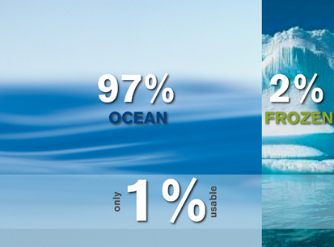

**Water Facts**

* There is the same amount of water on Earth as there was when the Earth was formed. The water from your faucet could contain molecules that dinosaurs drank.
* Water is composed of two elements, Hydrogen and Oxygen. 2 Hydrogen + 1 Oxygen = H2O.
* Nearly 97% of the world’s water is salty or otherwise undrinkable. Another 2% is locked in ice caps and glaciers. That leaves just 1% for all of humanity’s needs — all its agricultural, residential, manufacturing, community, and personal needs.
* Water regulates the Earth’s temperature. It also regulates the temperature of the human body, carries nutrients and oxygen to cells, cushions joints, protects organs and tissues, and removes wastes.
* 75% of the human brain is water and 75% of a living tree is water.
* A person can live about a month without food, but only about a week without water.
* Water is part of a deeply interconnected system. What we pour on the ground ends up in our water, and what we spew into the sky ends up in our water.
* The average total home water use for each person in the U.S. is about 50 gallons a day.
* The average cost for water supplied to a home in the U.S. is about $2.00 for 1,000 gallons, which equals about 5 gallons for a penny.
* Water expands by 9% when it freezes. Frozen water (ice) is lighter than water, which is why ice floats in water.

http://water.epa.gov/learn/kids/drinkingwater/waterfactsoflife.cfm